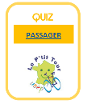PASSAGER
https://www.topquizz.com/quiz/P-Tit-Tour-USEP-quiz-passager-216269?key=73eee4968be88de27515406350e8a6a2

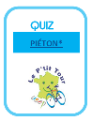PIETON – Niveau 1
https://www.topquizz.com/quiz/P-Tit-Tour-USEP-quiz-pieton-niveau-1-216236?key=d9898fe6a72a8bbb01566293bd027db4

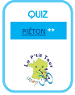PIETON – Niveau 2
https://www.topquizz.com/quiz/P-Tit-Tour-USEP-quiz-pieton-niveau-2-216250?key=a48230a3353ed805b72f0434ccc7325c

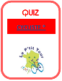
CYCLISTE – Niveau 1
https://www.topquizz.com/quiz/P-Tit-Tour-USEP-quiz-cycliste-niveau-1-216256?key=fae21a47663e452615c831aca4889307

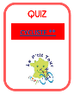CYCLISTE – Niveau 2
https://www.topquizz.com/quiz/P-Tit-Tour-USEP-quiz-cycliste-niveau-2-216258?key=f33641f152b8bbc2f1a916fa22ed8fec

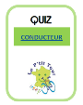CONDUCTEUR
https://www.topquizz.com/quiz/P-Tit-Tour-USEP-quiz-conducteur-216275?key=6fe3239fe18dee1404110a8fc2b1a9a7

